- Access Access Data File
1.1 Open Access Data File: Click on “Open”
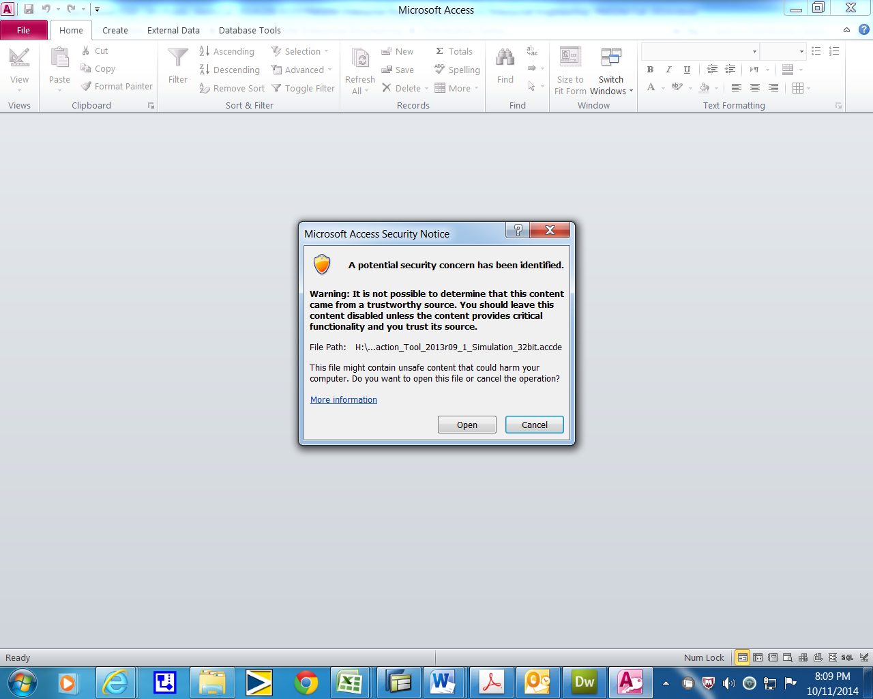
1.2 Click on a liitle key to open a list for tables and queries
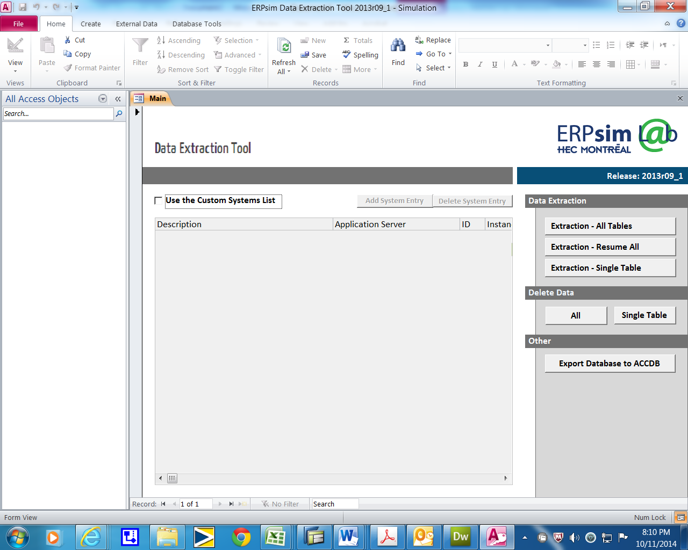

1.3 A list of tables and queries are shown. Select the table or query that you want to analysis.
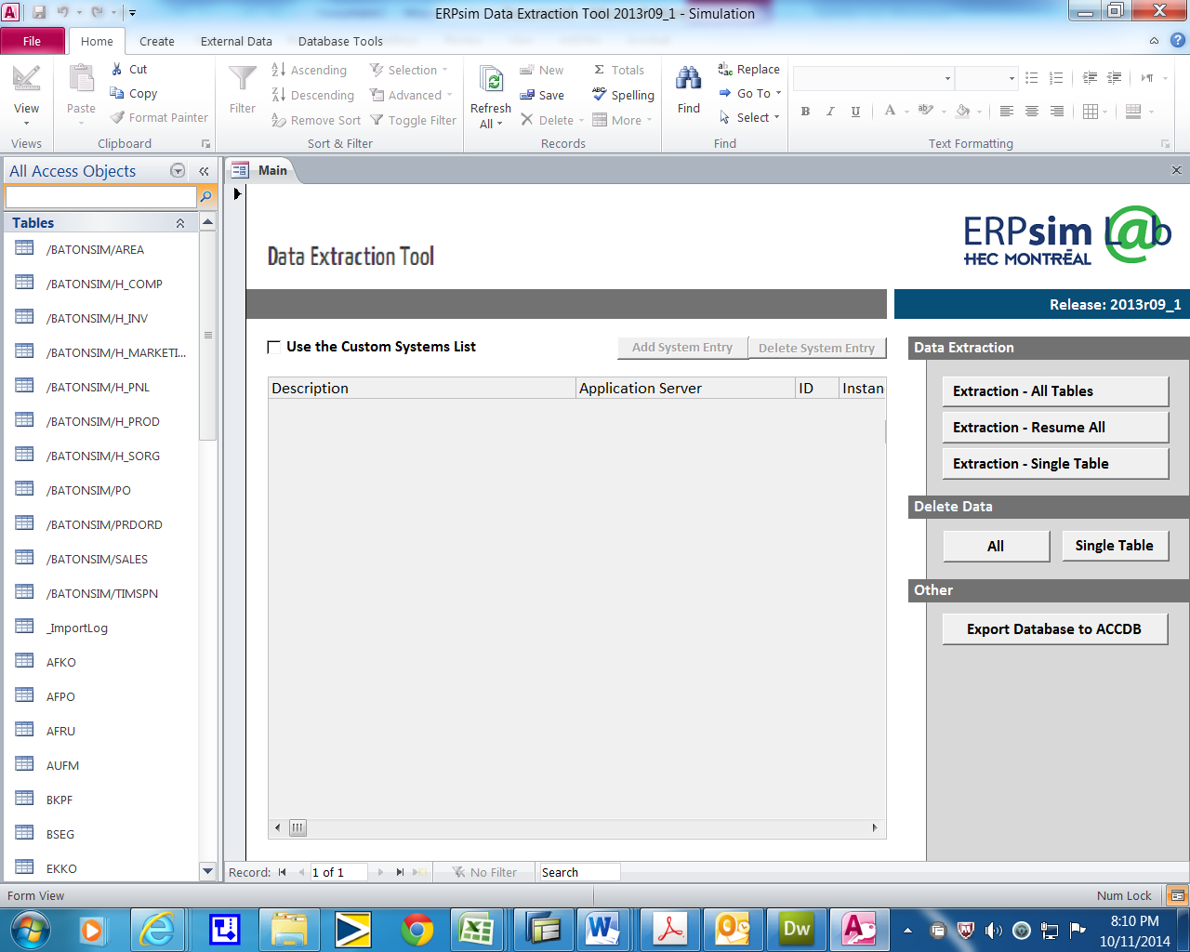
1.4 The selected query “ERPsim – Sales is opend.
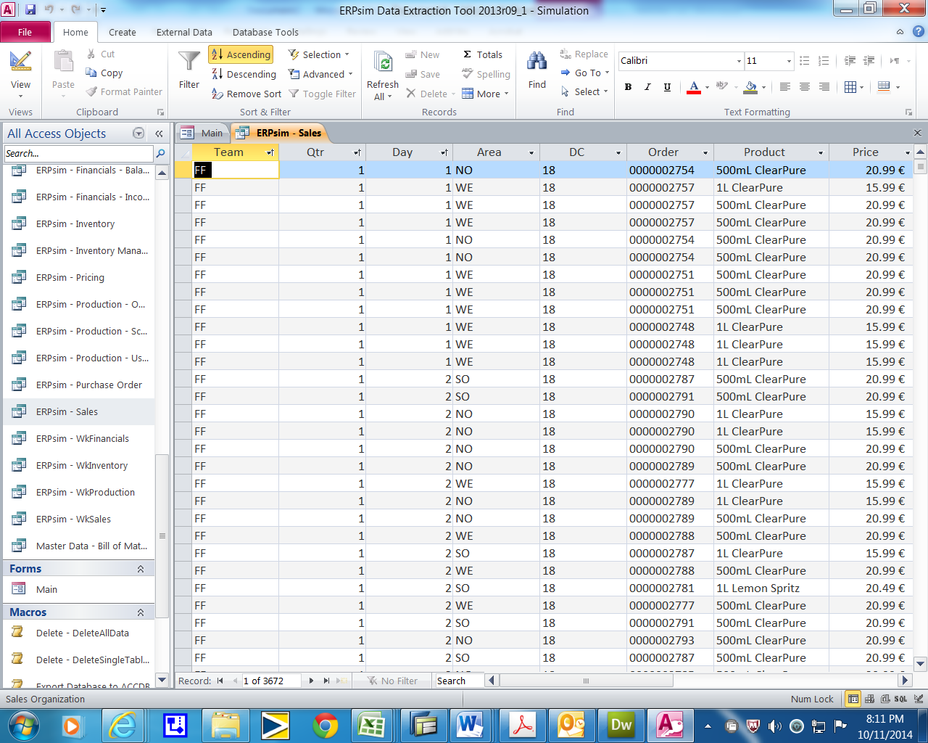

- Upload Access file to Excel
2.1 Select “Data” tab and clickon “From Access”


2.2 On a new pop-up screen, click on OK.
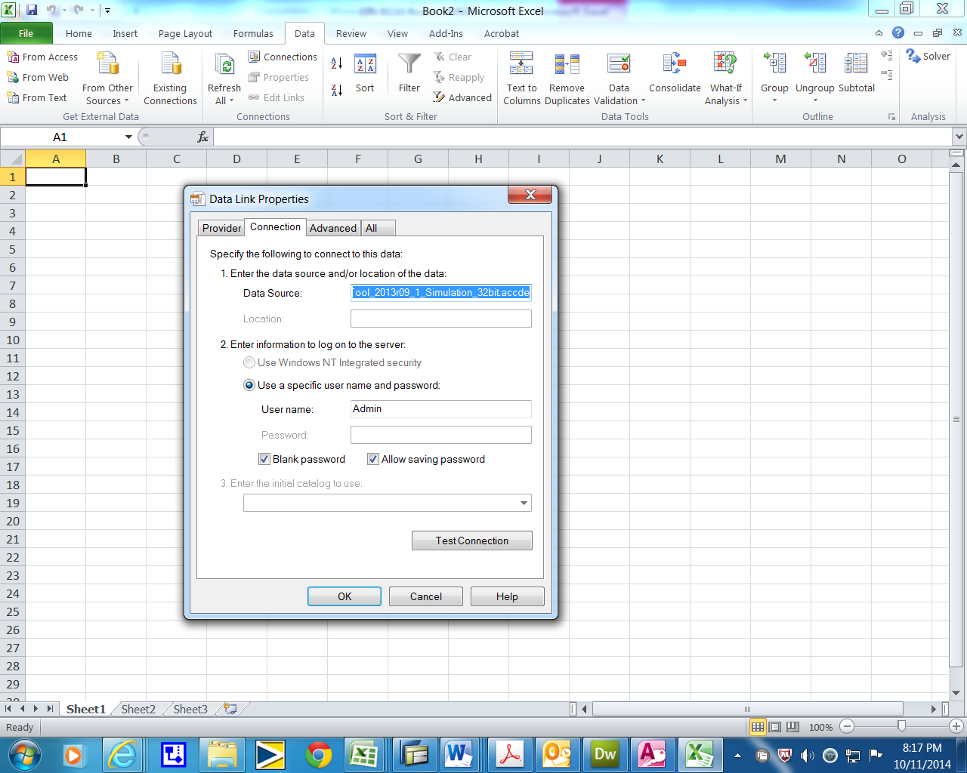

2.3 Click “OK” again
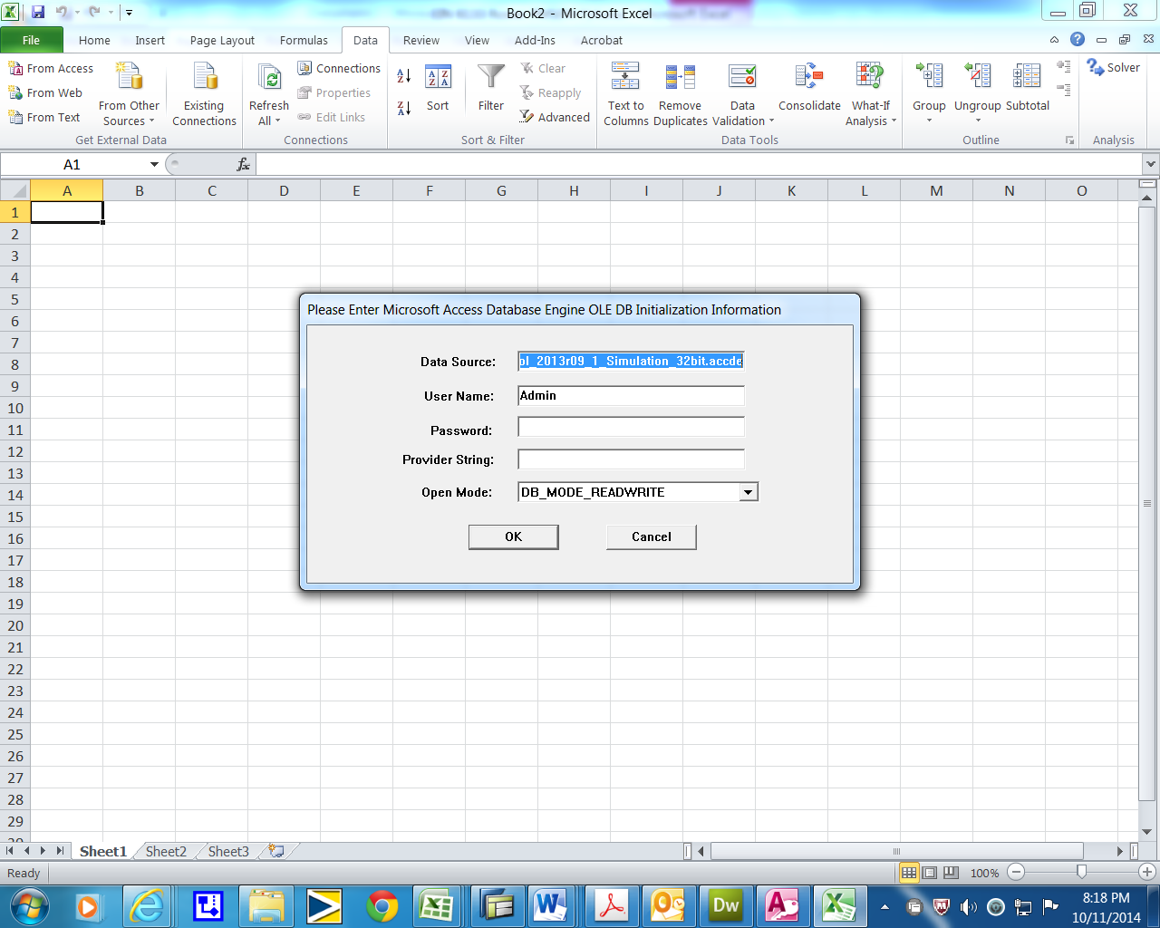
2.4 Select a table or query you want to do analysis in Excel and click OK.
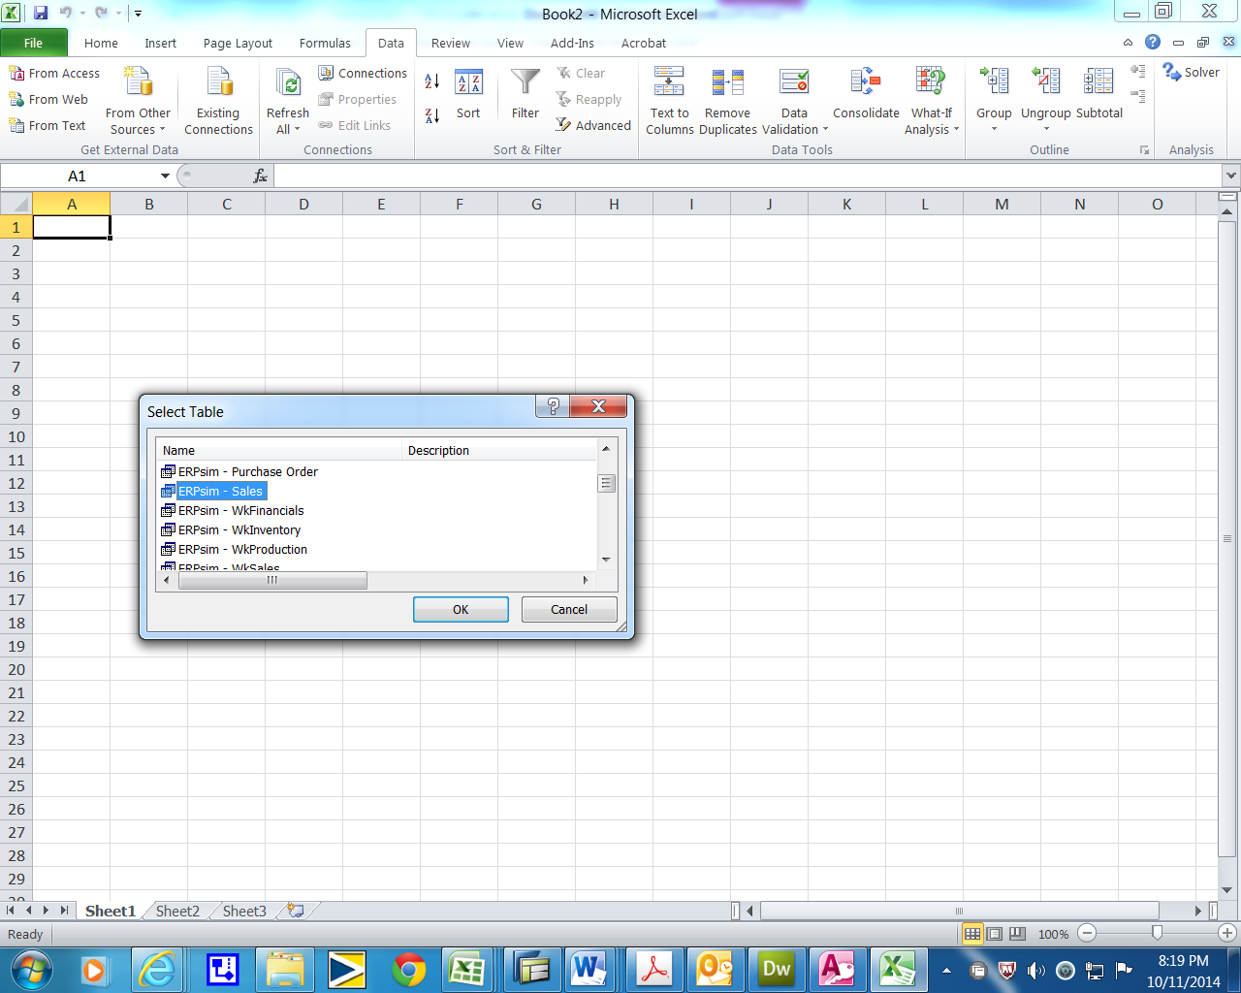

2.5 Click OK again. If you want select PivotTable, then select it first, then click ok.
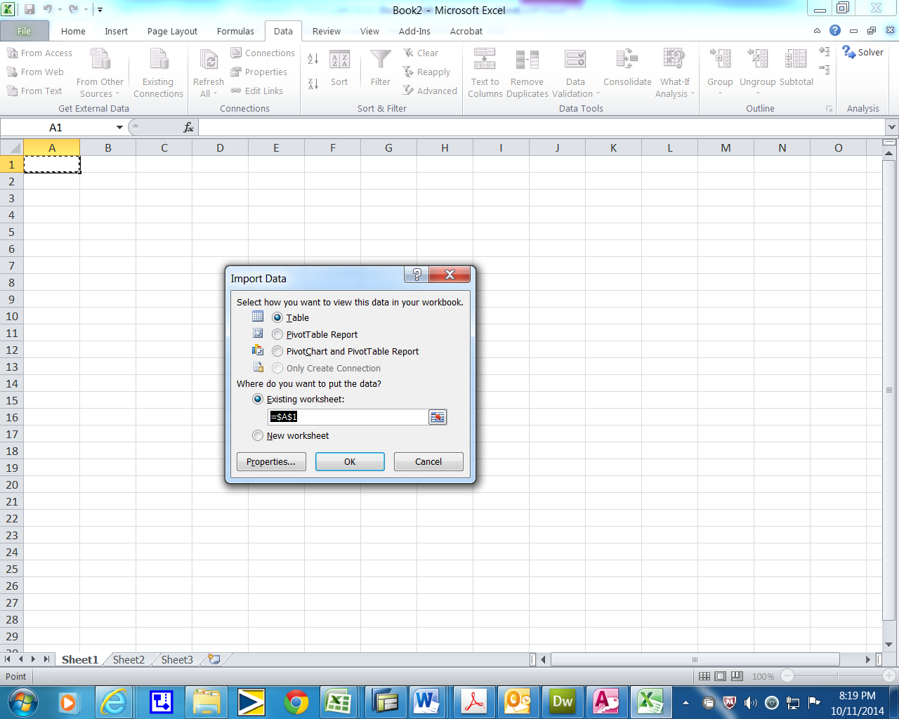
2.6 The table or query is uploaded in Excel.
